***Supporting Document: Sign & Spell VR***

**Name:** Karl Negrillo  
**Student Number:** C22386123  
**Supervisor:** Colette Kirwan  
**Project Title:** Sign & Spell VR: ISL Alphabet and Word Practice in Virtual Reality

***Code***

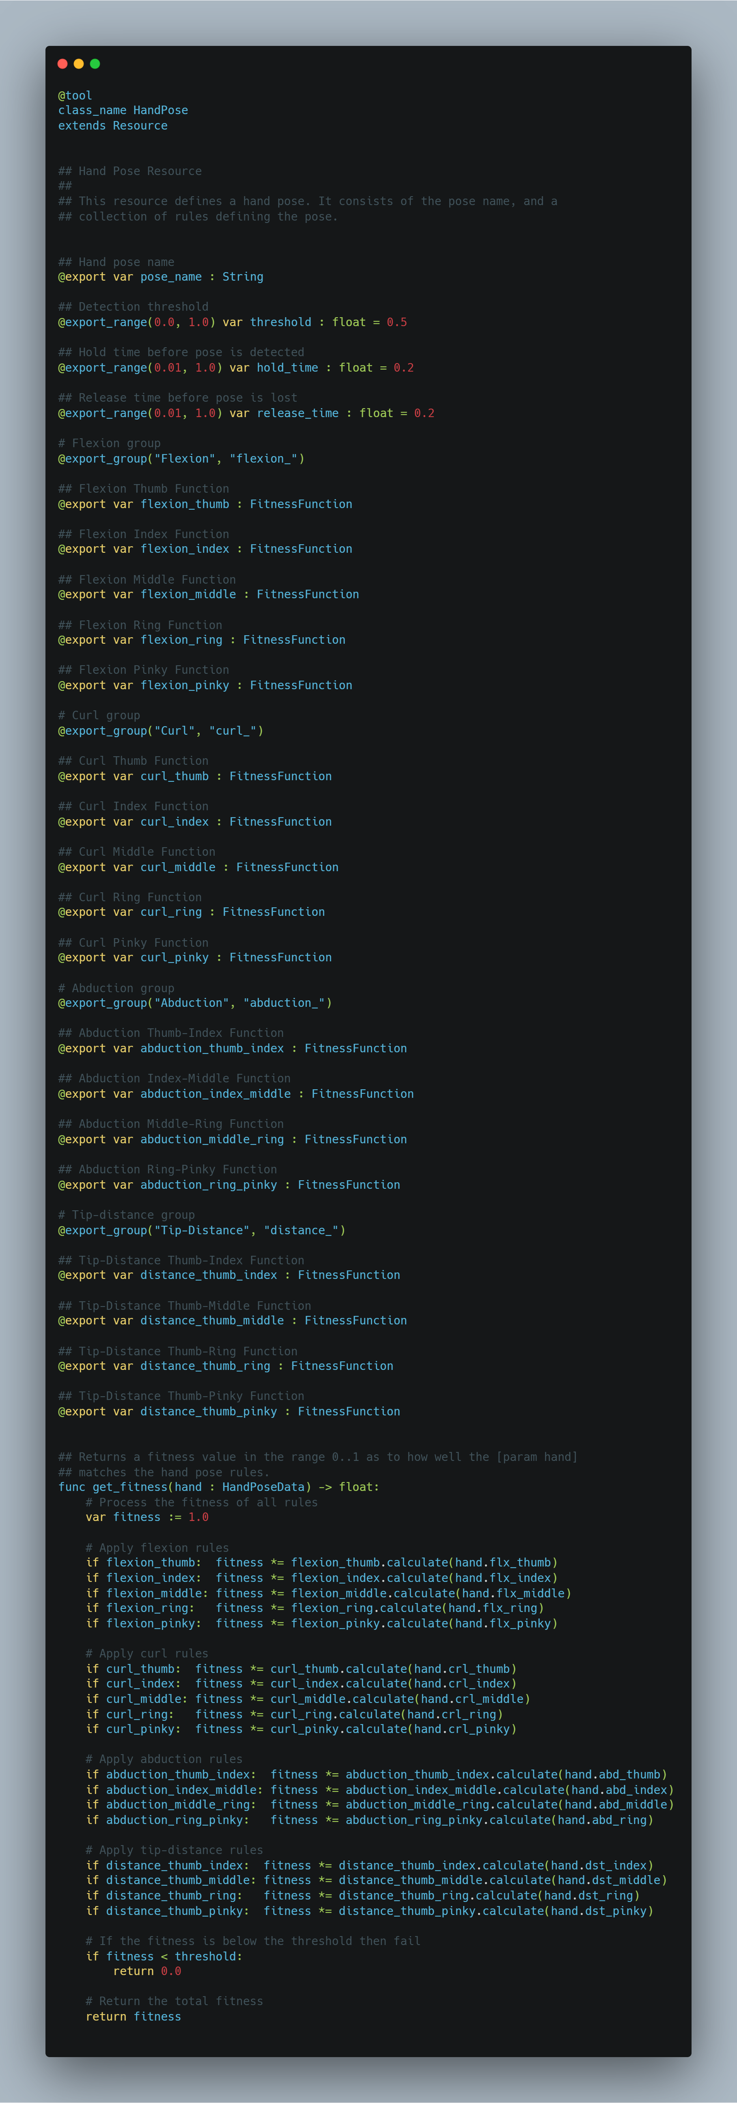

*Figure 1: hand_pose.gd GDScript Code*

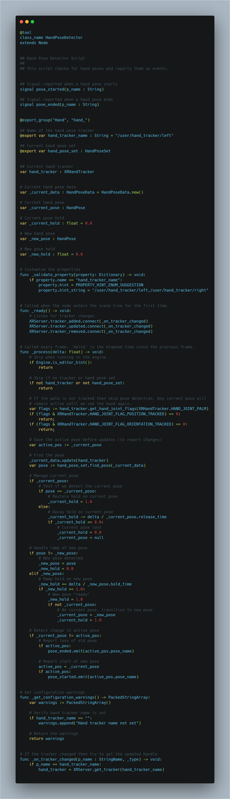

*Figure 2: hand_pose_detector.gd GDScript Code*

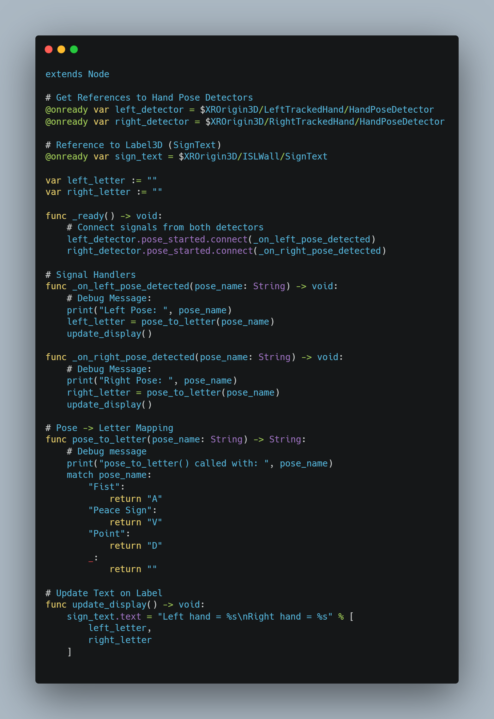

*Figure 3: sign_feedback.gd GDScript Code*

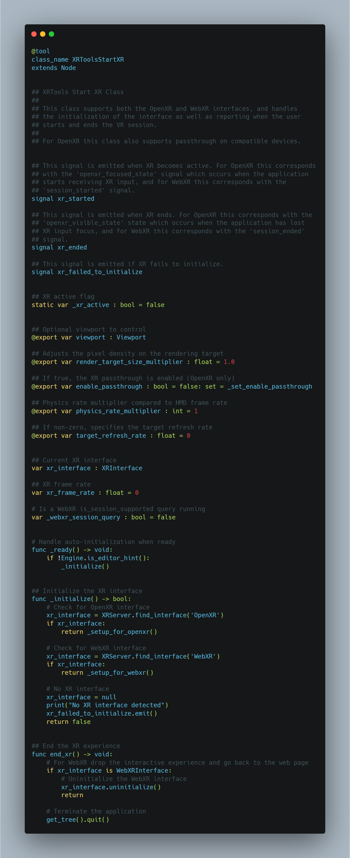

*Figure 4: start_xr.gd GDScript Code*

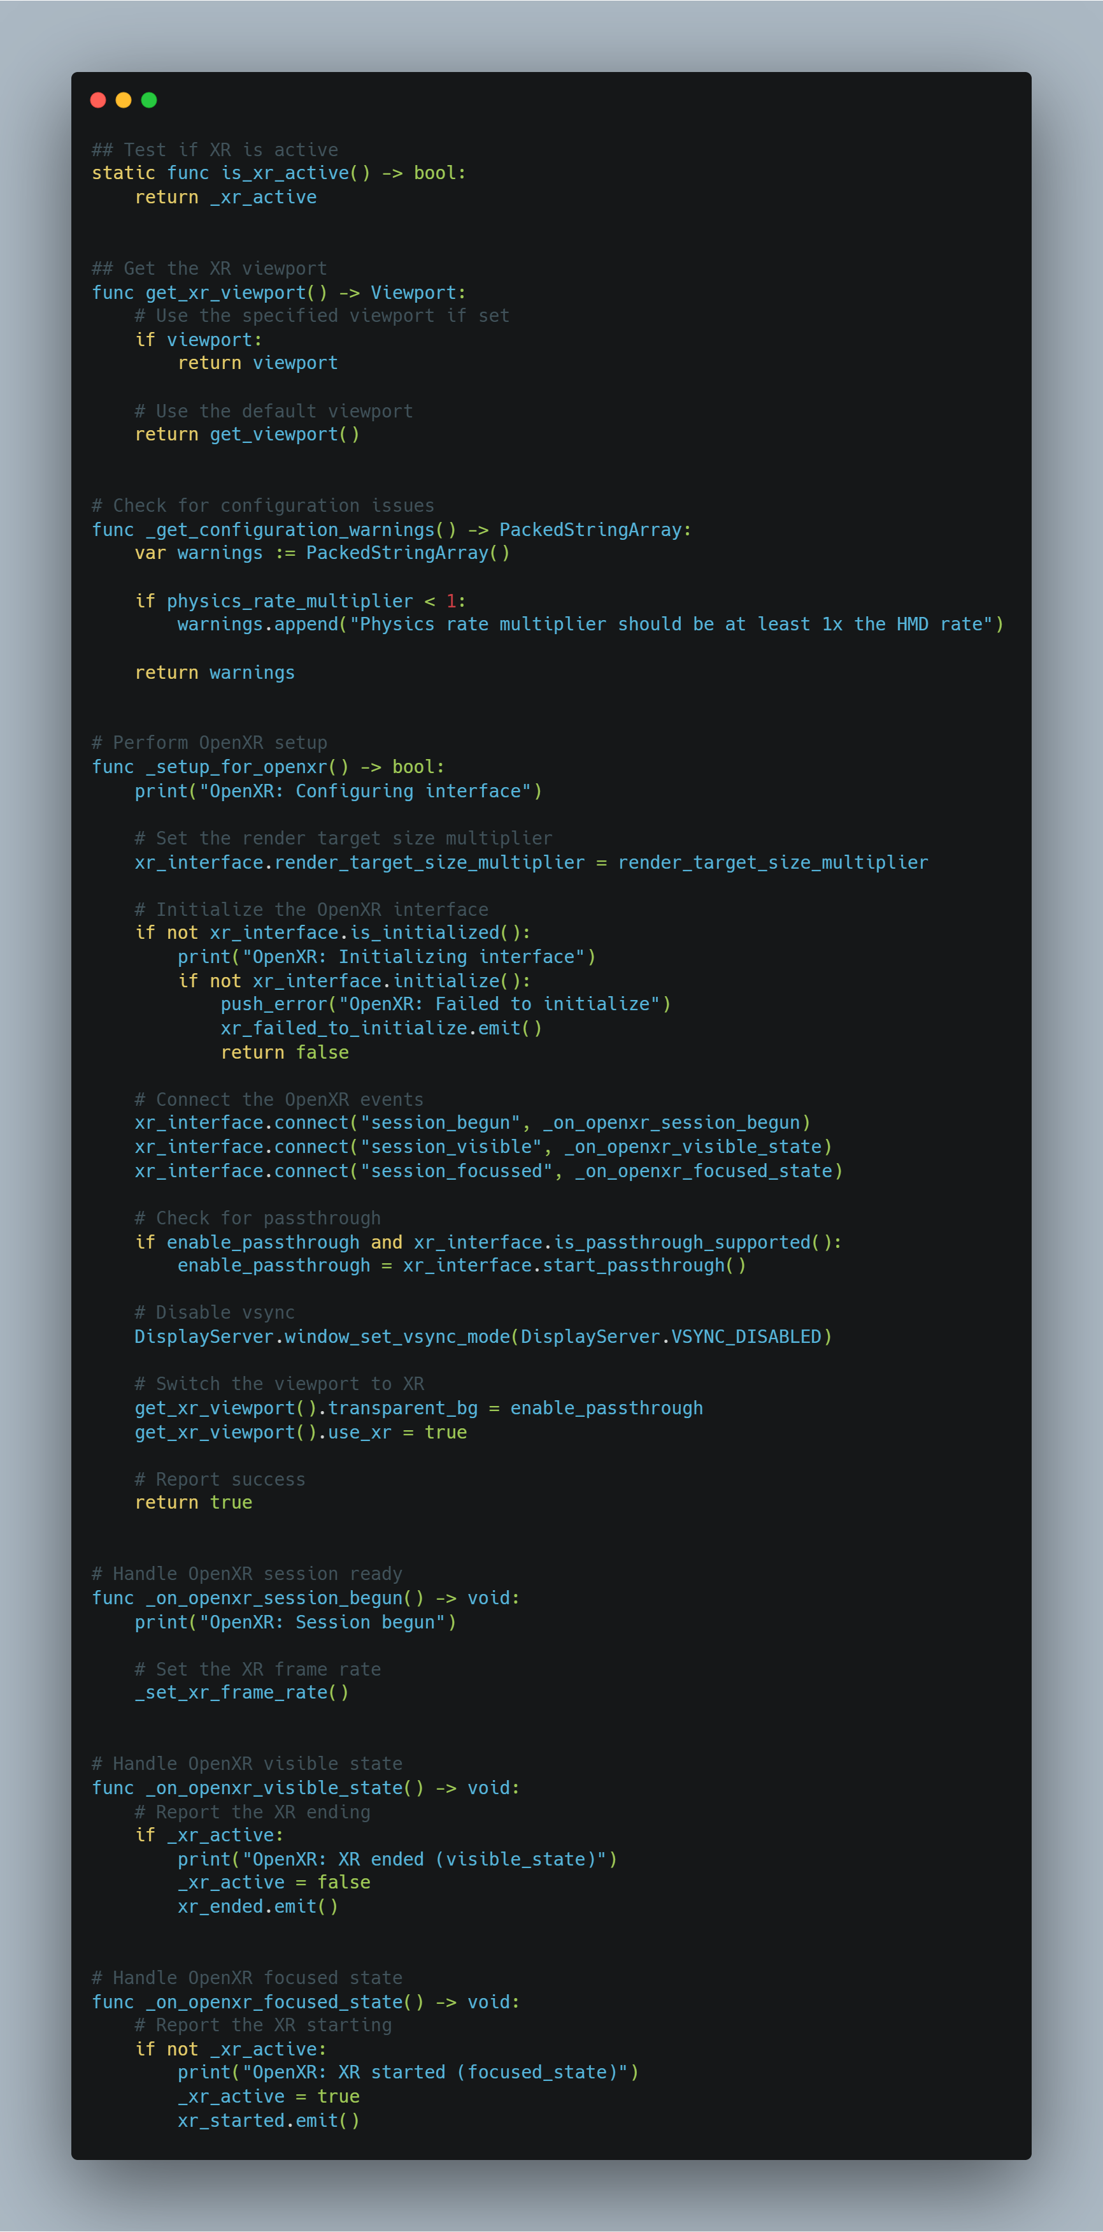

*Figure 4.1: start_xr.gd GDScript Code*

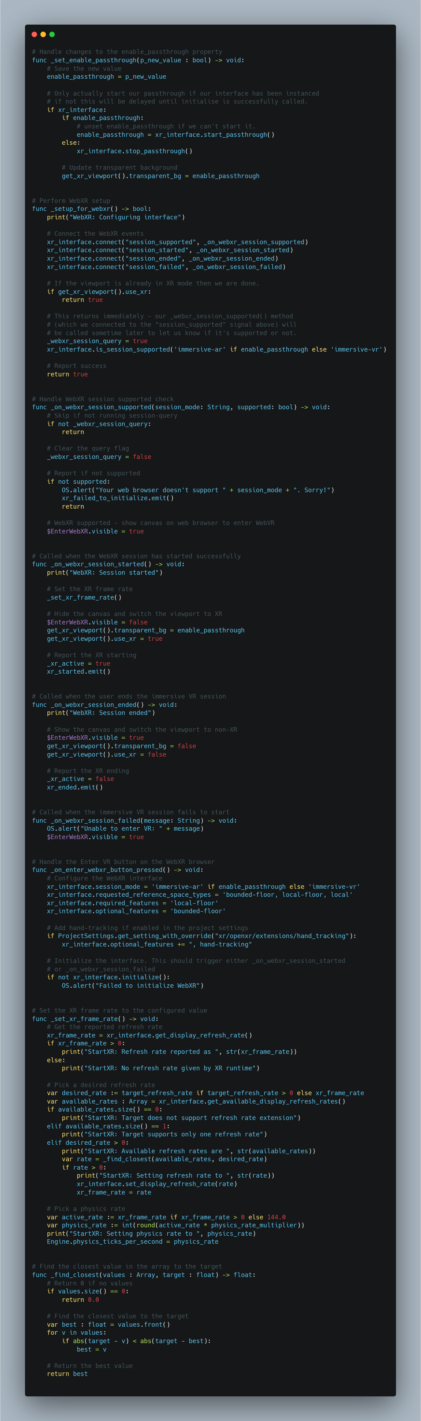

*Figure 4.2: start_xr.gd GDScript Code*

***Screenshots***

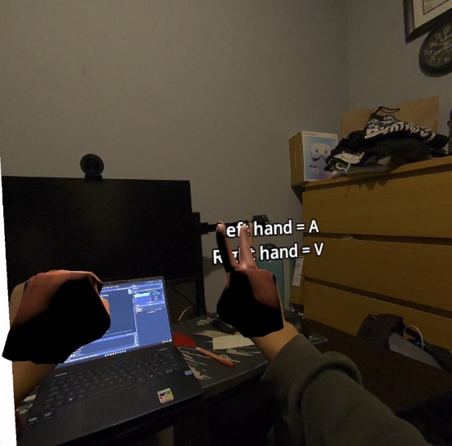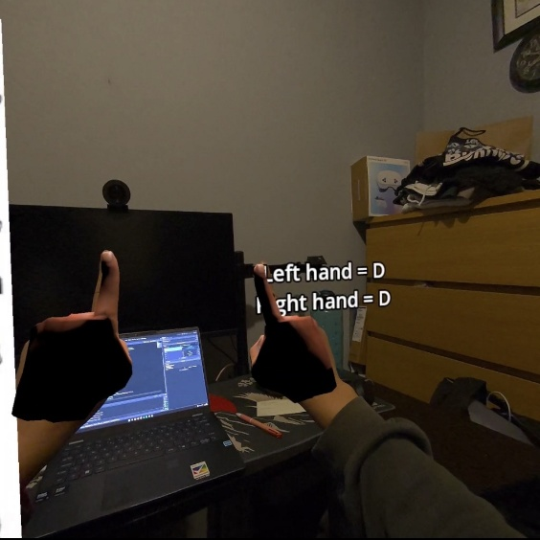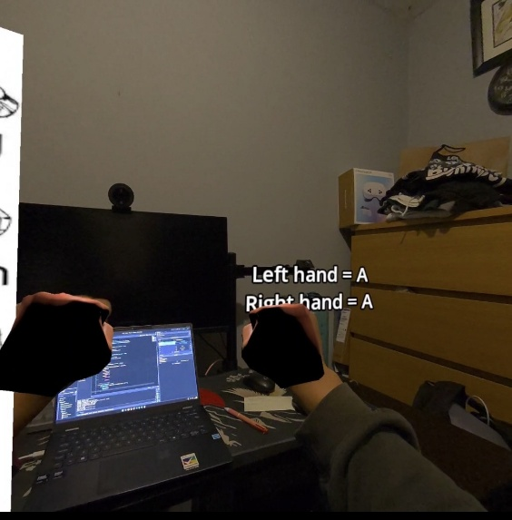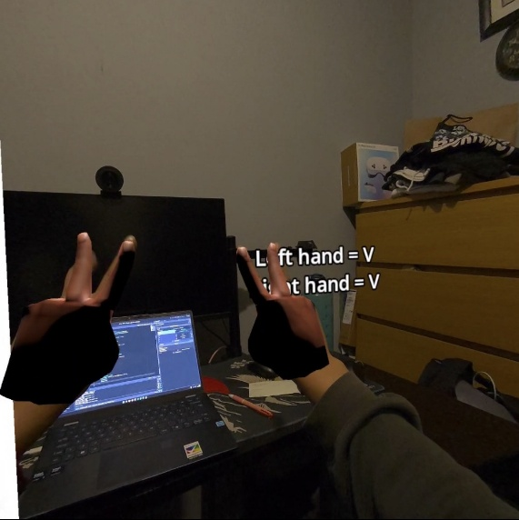**Tests**

*Figure 5: Test For Signing “A” Figure 5.1: Test For Signing “V”*

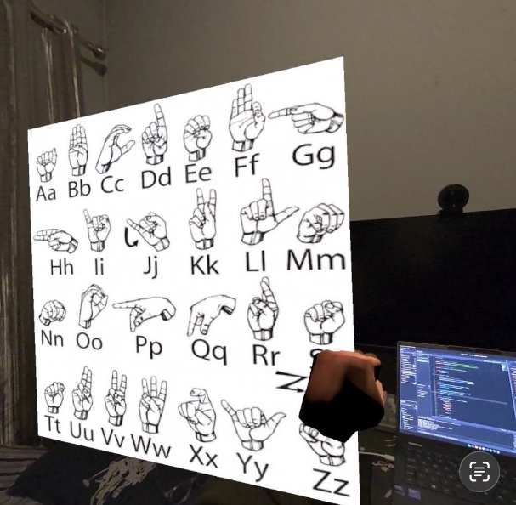 *Figure 5.2: Test For Signing “D” Figure 5.3: Test For Signing “A” and “V” on hands*

*Figure 5.3: Irish Sign Language Wall on Environment*

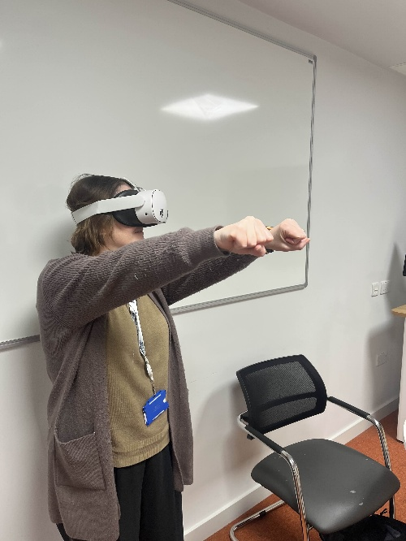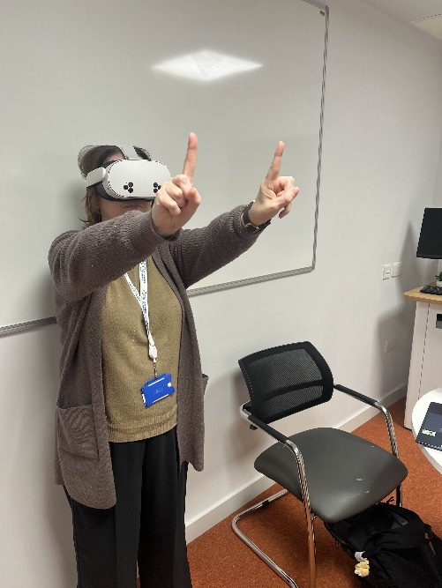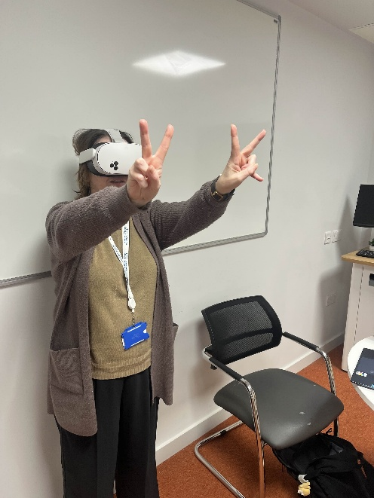

*Figure 6: Supervisor Testing Prototype*

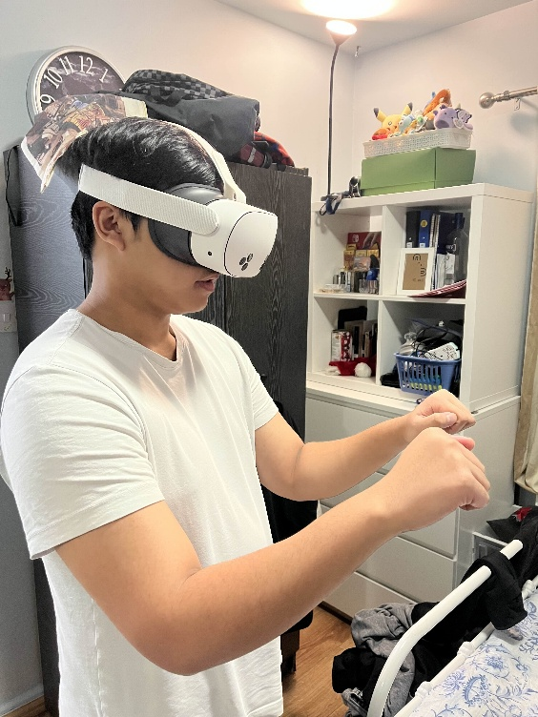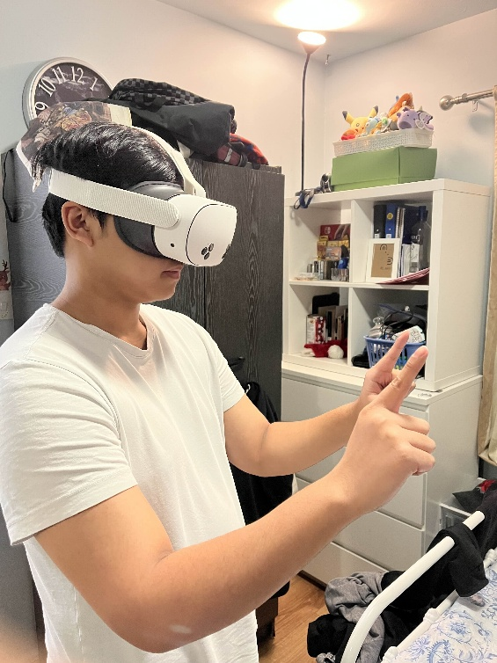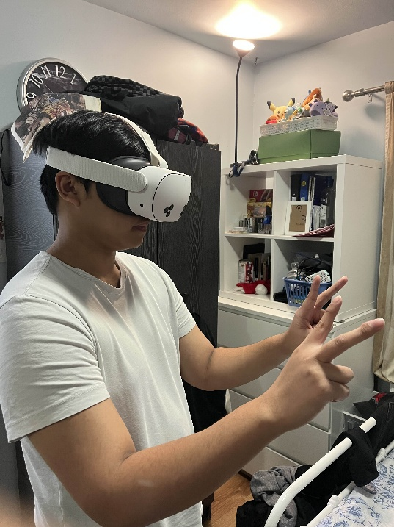

*Figure 7: User Testing Prototype*

**Hierarchy**

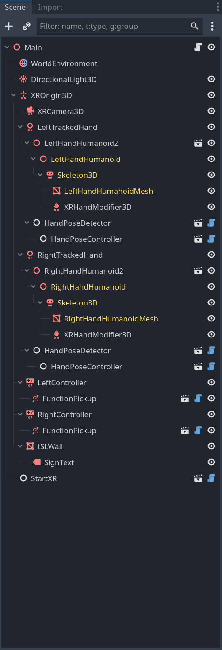

*Figure 8: Current Hierarchy for Prototype*

**Config**

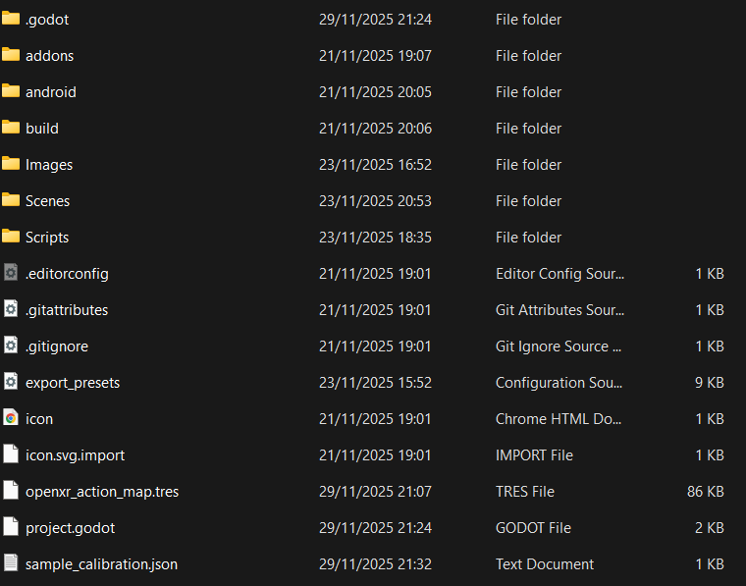

*Figure 9: Config for Sign & Spell VR*